CST-310 · Topic 8

Lab Question 2

Question
Carefully read the description of Project 8. Create an algorithm for generating a sphere. Post screenshots of your algorithm.

Approach
The sphere is built procedurally with the classic latitude/longitude (UV-sphere) parameterization: rings of latitude ("stacks") from pole to pole, each ring subdivided into wedges of longitude ("slices"). Because the sphere is a unit sphere centered at the origin, the outward normal at any vertex is simply that vertex’s position, normalized — no separate normal calculation is needed.

Algorithm
- Choose the number of stacks (latitude rings) and slices (longitude wedges). More of each → a rounder silhouette and more triangles.
- For i = 0 .. stacks: let phi = π·i/stacks (0 at the north pole, π at the south pole). Compute sphi = sin(phi), cphi = cos(phi).
- For j = 0 .. slices: let theta = 2π·j/slices. Compute x = sphi·cos(theta), y = cphi, z = sphi·sin(theta).
- Push (x, y, z) as the position AND, unchanged, as the normal — for a unit sphere centered at the origin, normal = position.
- After all (stacks+1)×(slices+1) vertices are generated, build the index buffer. For each quad (i, j) with i < stacks, j < slices, take its four corners a, b, c, d (using cols = slices+1: a = i·cols+j, b = (i+1)·cols+j, c = (i+1)·cols+(j+1), d = i·cols+(j+1)) and emit triangles (a, b, c) and (a, c, d).
- Upload to a VBO/EBO with 6 floats per vertex (position, normal) and draw with glDrawElements(GL_TRIANGLES, indexCount, GL_UNSIGNED_INT, 0).
- Known limitation: every triangle at i = 0 and i = stacks converges on a single pole vertex, which pinches shading/texturing at the poles. An icosphere (subdivided icosahedron, normalized to the unit sphere) avoids this but is out of scope here.

Flowchart
Start
↓
Set stacks, slices
↓
For i = 0..stacks, j = 0..slices: phi, theta → (x, y, z); push as position + normal
↓
All vertices generated?
↓
For each (i, j) quad: emit 2 triangles into the index array
↓
Upload vertices → VBO, indices → EBO
↓
Render loop: bind VAO, glDrawElements(GL_TRIANGLES, …)
↓
End

Reference implementation
Full source: code/sphere_mesh.cpp.
static void build_sphere(int stacks, int slices,
std::vector<float>& verts, std::vector<unsigned int>& idx) {
const float PI = 3.14159265358979323846f;
for (int i = 0; i <= stacks; ++i) {
float phi = PI * float(i) / stacks;
float sphi = std::sin(phi), cphi = std::cos(phi);
for (int j = 0; j <= slices; ++j) {
float theta = 2.0f * PI * float(j) / slices;
float x = sphi * std::cos(theta);
float y = cphi;
float z = sphi * std::sin(theta);
verts.push_back(x); verts.push_back(y); verts.push_back(z); // position
verts.push_back(x); verts.push_back(y); verts.push_back(z); // normal == position
}
}
int cols = slices + 1;
for (int i = 0; i < stacks; ++i)
for (int j = 0; j < slices; ++j) {
unsigned int a = i * cols + j, b = (i + 1) * cols + j;
unsigned int c = (i + 1) * cols + (j + 1), d = i * cols + (j + 1);
idx.push_back(a); idx.push_back(b); idx.push_back(c);
idx.push_back(a); idx.push_back(c); idx.push_back(d);
}
}

Screenshots of the algorithm running
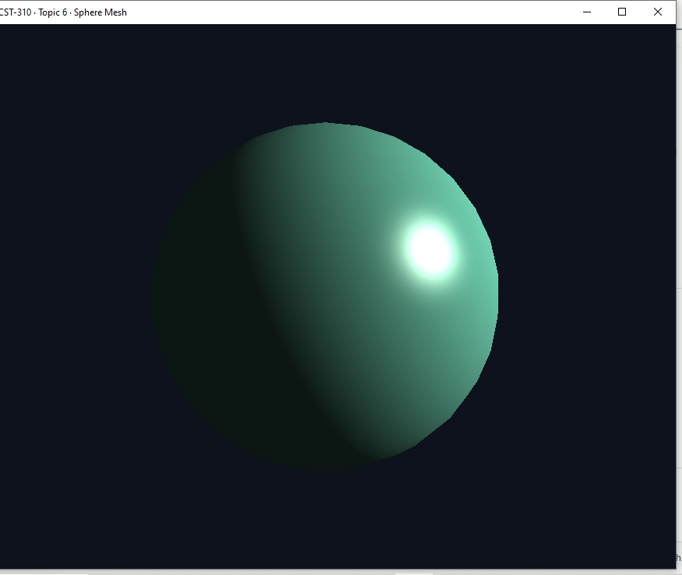
Blinn-Phong shaded sphere, resolution level 4 (32 slices / 16 stacks).
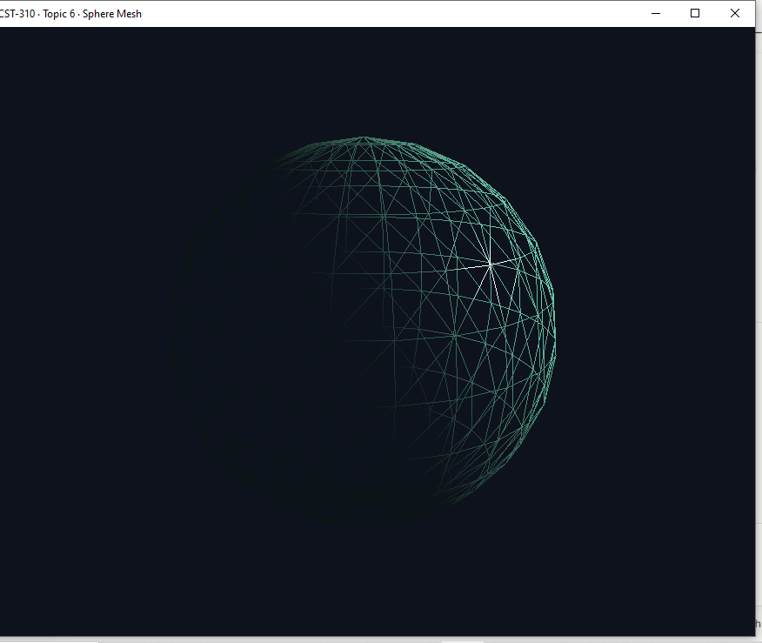
Same mesh, wireframe mode (W key) at resolution level 3 — the lat/long triangulation from the algorithm above is directly visible, including the pole convergence.

GitHub
Repository link: <add link after upload>

